**Standards for documentation**

In order to make this process easy to understand for new users, we must provide proper documentation. For each step in the documentation, show screenshots of the output and commands used. Then, provide a clear description underneath each screen shot. Use times new roman, size 14, and 1 inch margins.

FORMATTING OF EACH STEP:

**Step #:**

Explanation text

[Image goes here]

Explanation text

Below is an example of what the documentation should look like.

**How to update all your packages on linux**

**Step 1:**

Open the terminal

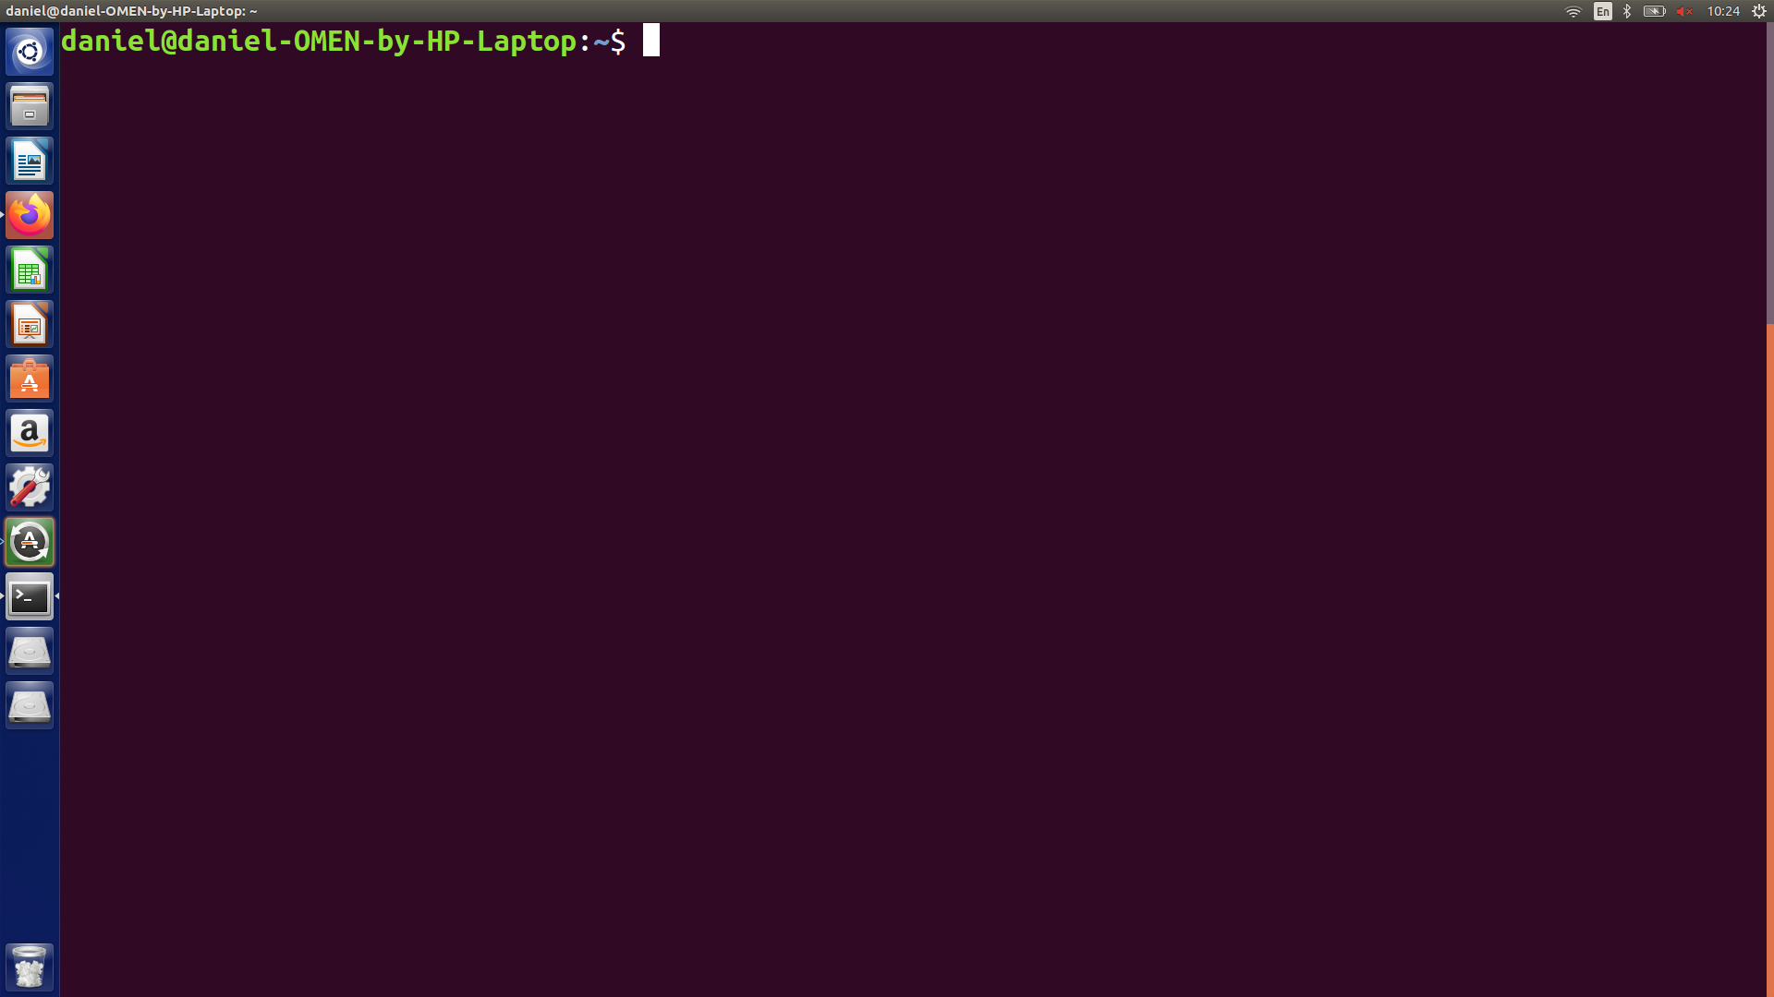

This can be done by pressing CTRL+ALT+T.

**Step 2:**

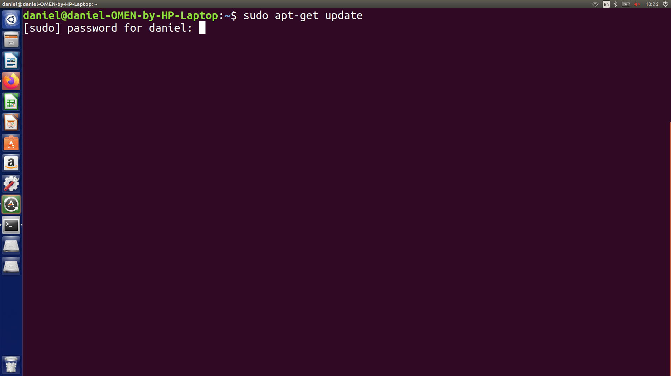

Type in sudo apt-get update

This command will get all the updates for your packages (but it wont update them yet), but you must first enter in your password. Below is the output after putting in your password.

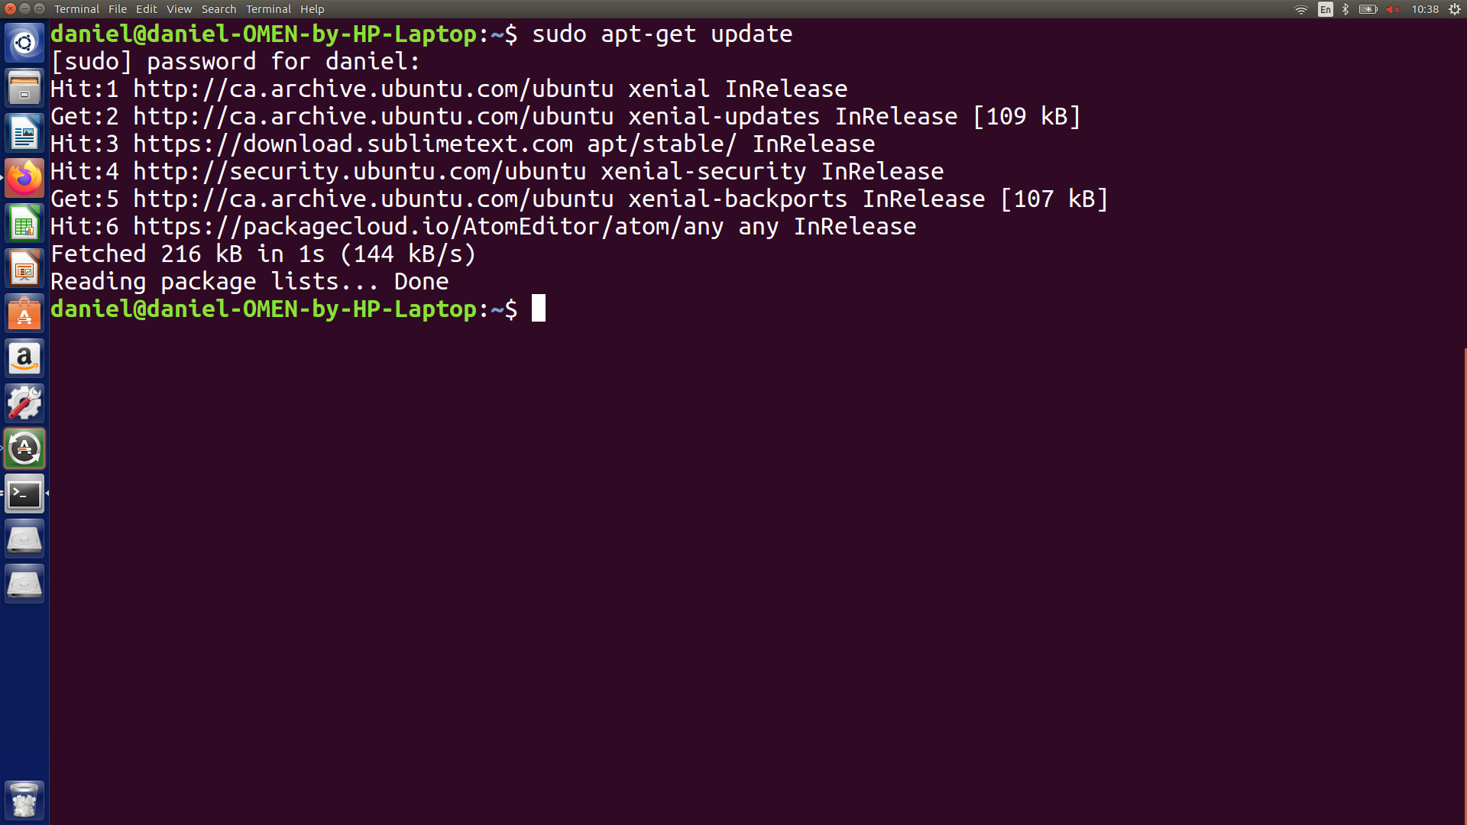

**Step 3:** Installing the updates

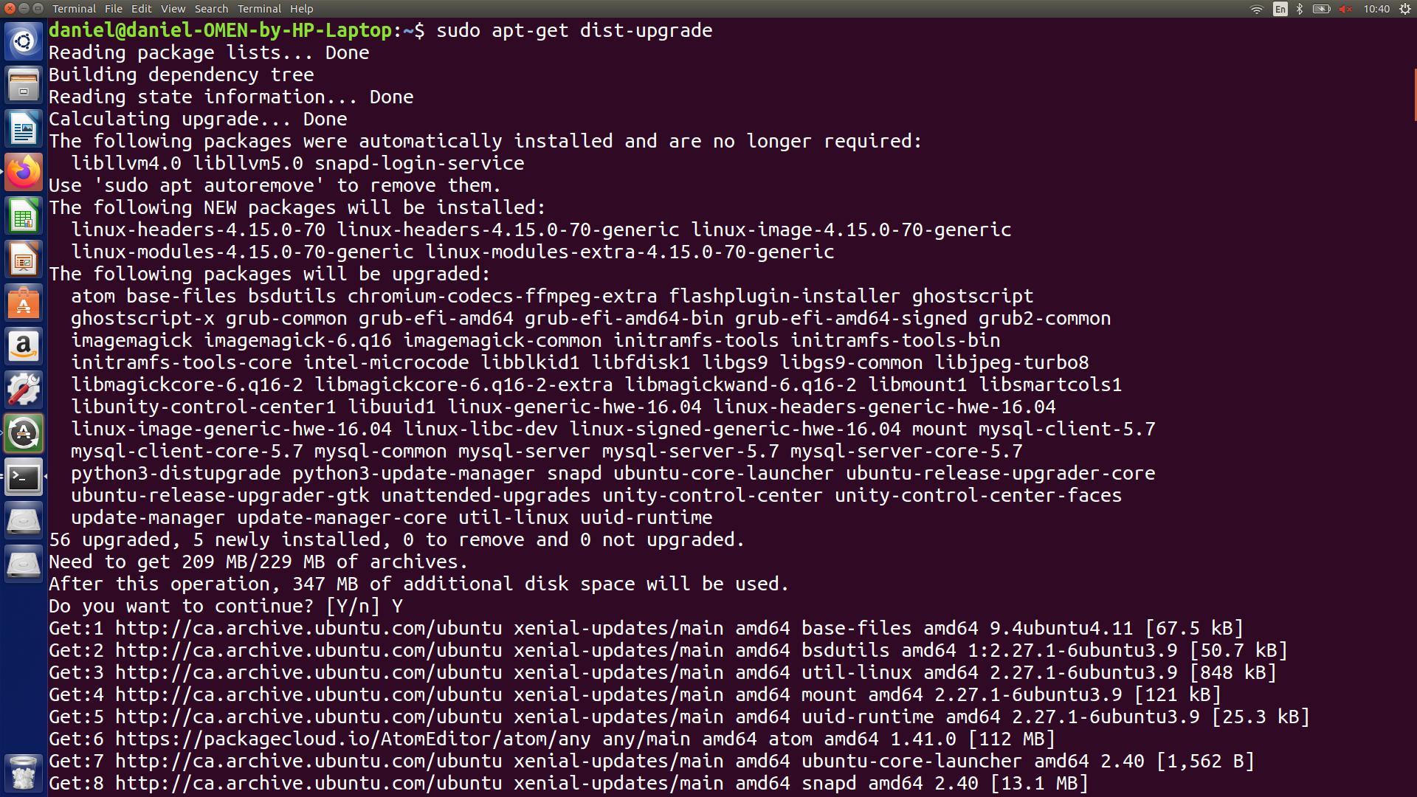

Type in sudo-apt upgrade

This will install all the updates to your packages. When prompted, type in your password, and then type Y when it asks if you want to continue.